**DAILY ONLINE ACTIVITIES SUMMARY**

|  |  |  |  |  |  |  |  |  |
| --- | --- | --- | --- | --- | --- | --- | --- | --- |
| **Date:** | **11/06/2020** | | | | | **Name:** | **RITIKA KULKARNI** | |
| **Sem& Sec** | **4thSEM. & ‘B’ SEC.** | | | | | **USN:** | **4AL19CS403** | |
| **Online Test Summary** | | | | | | | | |
| **Subject** | | **--** | | | | | | |
| **Max. Marks** | | **--** | | **Score** | | | **--** | |
| **Certification Course Summary** | | | | | | | | |
| **Course** | **Introduction of Cyber Security** | | | | | | | |
| **Certificate Provider** | | | **Greatlearning**  **Academy** | | **Duration** | | | **5 Hrs.** |
| **Coding Challenges** | | | | | | | | |
| **Problem Statement:**   1. **Given an array A[], write a function that segregates even and odd numbers. The functions should put all even numbers first, and then odd numbers.**   **Example:**  **Input = {12, 34, 45, 9, 8, 90, 3}**  **Output = {12, 34, 8, 90, 45, 9, 3}** | | | | | | | | |
| **Status: Executed** | | | | | | | | |
| **Uploaded the report in Github** | | | | | **Yes** | | | |
| **If yes Repository name** | | | | | <https://github.com/ritikakulkarni> | | | |
| **Uploaded the report in slack** | | | | | **Yes** | | | |

**Certification Course Summary: Today, I learnt** **Career and Industry Landscape and**

**About speakers and so on.**

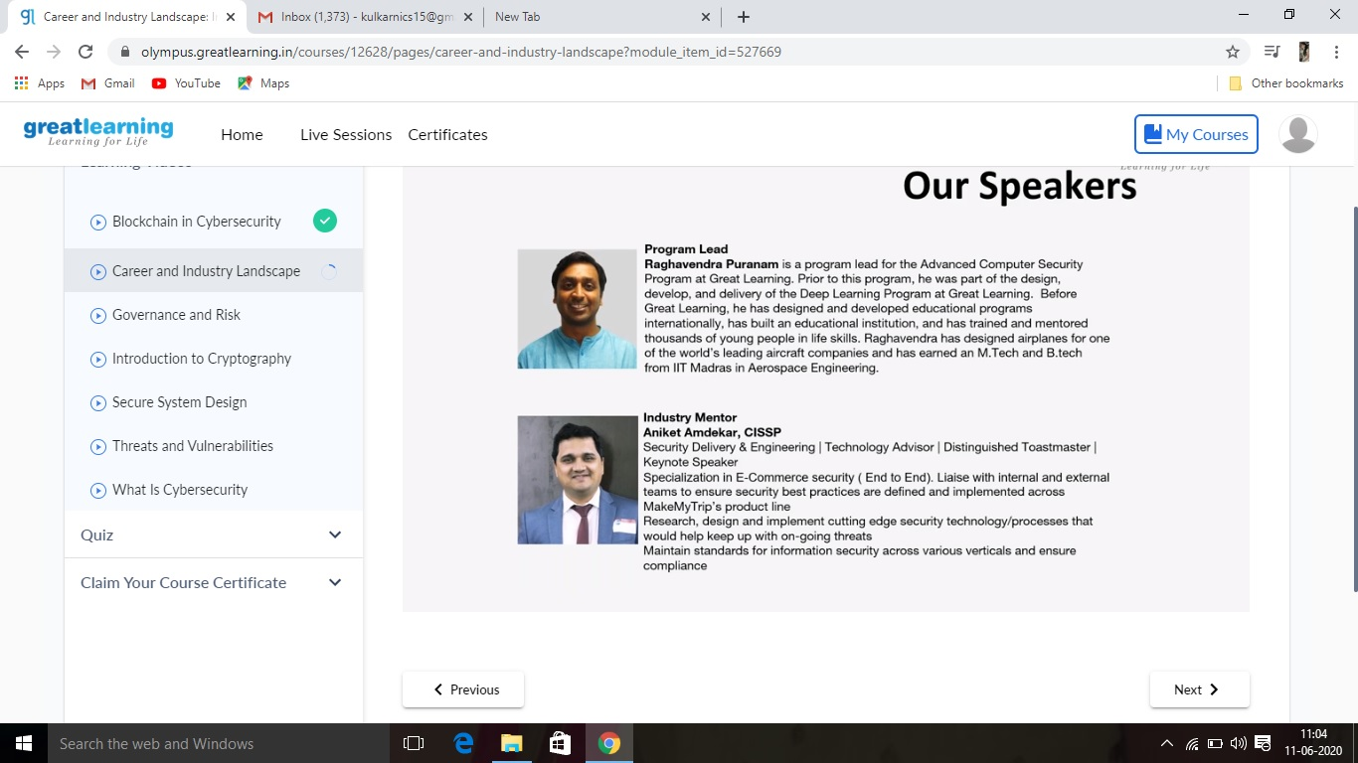

**Online Coding Summary: Online Coding Summary​: Online coding Summary: Today I received two program from Shilpa Mam CSE Dept. The program is mentioned above(pg.01). to my GitHub repository and I’ve shared the snapshot below.**

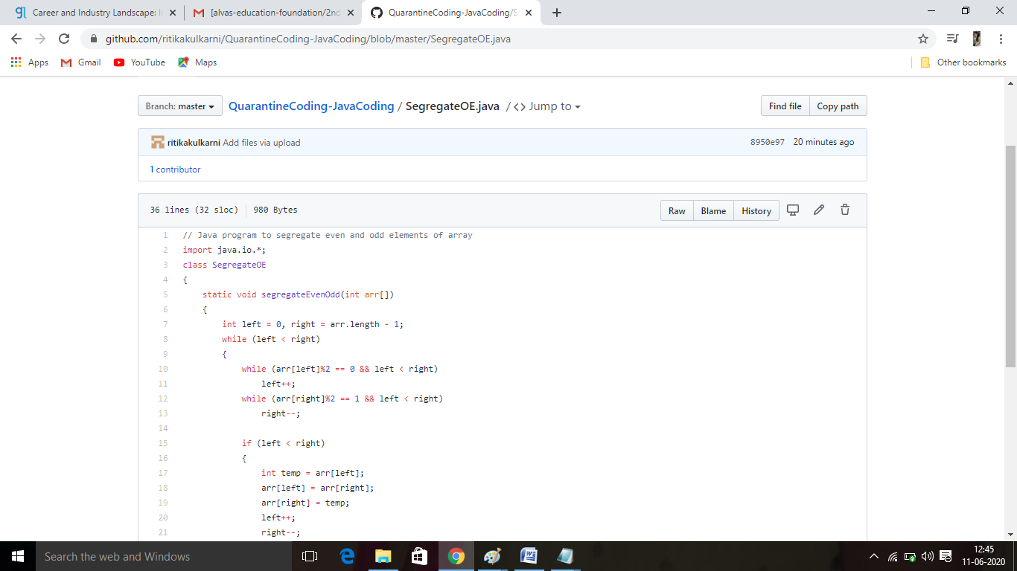

**Thank you.**